**ENM ENVIRONMENTAL INITIATIVES FUND**

**(EIF)**

**Guidelines – Small Grants 2024-25 ($1,000 or less, exclusive of GST)**

# **PLEASE READ CAREFULLY BEFORE COMPLETING THE APPLICATION FORM**

For questions or assistance please contact or drop in to see:

Kerry Jaques

Environment Network Manawatu

145 Cuba Street, Palmerston North

Phone: 06 355 0126

Email: [admin@enm.org.nz](mailto:admin@enm.org.nz)

# BACKGROUND INFORMATION FOR THE ENM ENVIRONMENTAL INITIATIVES FUND (EIF) – Small Grants

## The Purpose of the Fund

The main purpose of the grant is to support community initiatives that align with priorities of both PNCC and ENM to improve environmental outcomes for the city. Grants will be available to projects taking place within Palmerston North's City boundaries.

ENM sets the funding priorities each year based on identified priorities of the network and its partners.

Applications may be made for Small Grants (up to $1,000, exclusive of GST).

## EIF Priorities and Criteria 2024/25

Funding initiatives for the 2024/2025 funding round must demonstrate alignment with the following priorities and criteria for eligibility. Priorities are reviewed annually by the ENM Board.

**Priorities**

### Community Food Sovereignty

*Initiatives that enhance community wellbeing by improving food resilience, food security and food sovereignty.*

*Food resilience is defined as:*

*“a system that ensures food security”*

*Food security is defined as:*

*“a sufficient supply of acceptable and accessible food for everyone who requires it, under any circumstances”*

*Food sovereignty is defined as:*

*“the right of peoples to healthy and culturally appropriate food produced through ecologically sound and sustainable methods, and their right to define their own food and agriculture systems”*

*Examples of initiatives that align with this priority are:*

*Set up and development of community gardens.*

*Gardening and cooking programmes in schools.*

*Community composting initiatives.*

*Food and resource sharing initiatives.*

### Biodiversity Protection and Enhancement.

*Initiatives that protect and enhance biodiversity, and freshwater quality. Initiatives that enhance the mauri of the Manawatū River catchment.*

*Biodiversity is defined as:*

*“the variety of plant and animal life in the world or in a particular habitat, a high level of which is usually considered to be important and desirable”*

*Mauri is defined as;*

*“life force or essence”*

*Examples of initiatives that align with this priority are:*

*Predator control projects.*

*Weed control programmes.*

*Tree planting programmes.*

*Native species monitoring programmes.*

*Removal of plastics and other pollution from waterways.*

*Removal of weeds from waterways.*

*Water quality monitoring of our waterways.*

*Riparian planting (planting the areas beside waterways).*

*The establishment and maintenance of green spaces.*

### Circular Economy

*Initiatives that contribute to the minimisation of waste and promote the sustainable use of natural resources.*

*A Circular Economy is based on the following three principles: design out waste and pollution; keep products and materials in use; and regenerate natural systems.*

*Waste minimization is defined as:*

*“reduction in the quantity of hazardous wastes achieved through a conscientious application of innovative or alternative processes”.*

*Examples of initiatives that align with this priority are:*

*Systems that involve the shared use of existing materials and products.*

*Systems that involve the re-use of existing materials and products.*

*Upcycling or recycling initiatives.*

*Refurbishment programmes.*

*Community composting initiatives.*

*Initiatives aimed at stopping the use of plastics.*

*Initiatives that find creative ways of reusing everything.*

### Climate Action.

*Initiatives that involve climate change mitigation and adaptation.*

*Climate change mitigation means:*

*“avoiding or reducing emissions of heat-trapping greenhouse gases into the atmosphere to prevent the planet from warming to more extreme temperatures”.*

*Climate change adaptation measures aim to reduce vulnerability to the effects of climate change.*

*Examples of initiatives that align with this priority are:*

*These will include actions that support emission reduction, degrowth, carbon sequestration, and advocacy for climate-focused policies.*

*Mitigation:*

*Harnessing new technologies.*

*Initiatives seeking to reduce energy use and utilise renewable energy. Improving efficiency of existing energy systems.*

*Changing management practices or consumer behaviour.*

*More efficient means of transport e.g., electric public transport, bicycle, shared transport.*

*Adaptation:*

*Providing secure facility locations and infrastructure e.g., water tanks.*

*Landscape restoration and reforestation.*

*Flexible and diverse cultivation systems in anticipation of extreme weather events.*

*Reducing consumerism and waste.*

*Altered food and recreational choices.*

**Local Focus-:**

The initiative must take place within Palmerston North City boundaries, or individuals or organisations must be able to clearly demonstrate benefit to Palmerston North City residents.

*You can find a link to an interactive map showing the city boundaries* [*here*](https://geosite.pncc.govt.nz/MapViewer/?map=8c372cd395c34ff5bd5b8038503bef36)

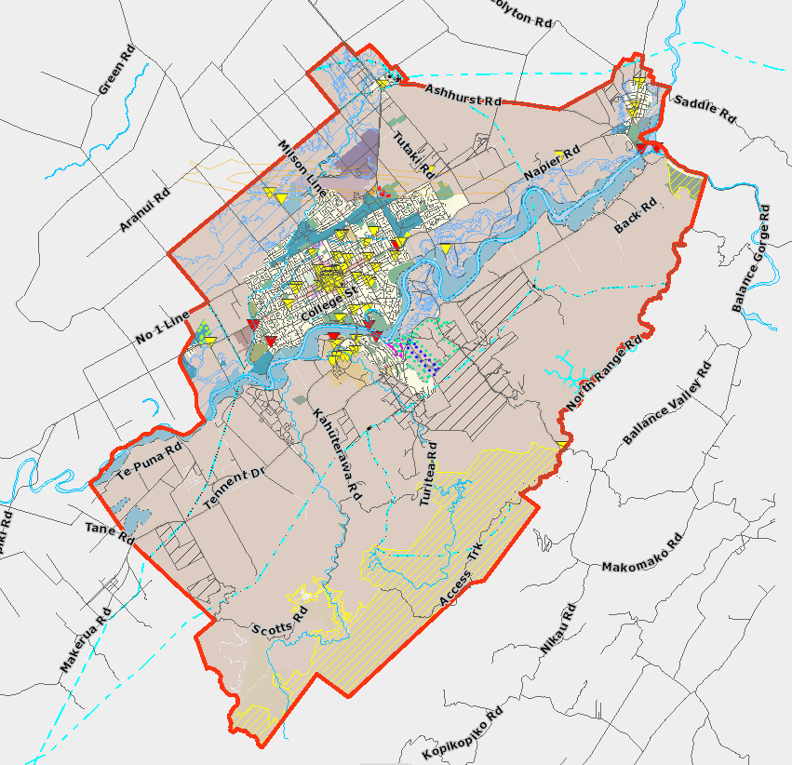

**Environmental Benefits**

The initiative must demonstrate the specific environmental benefits that will be achieved by implementing the initiative. Applicants should only apply for environmental initiatives that directly contribute to environmental outcomes. Initiatives that have an indirect environmental benefit are unlikely to be funded.

**Project Plan**

Applicants should submit a brief Project Planfor their initiative.The Plan should cover the objectives of the initiative, a description of how the objectives will be achieved and the timeline for the initiative. A Small Grant application need not be for a new activity but could cover maintenance or expansion of an existing initiative.

**Reporting**

Applicants will need to demonstrate how they will measure the initiative’s success – they will need the capability to record and report on the project’s success to ENM.

**Applicant Status**

Applications will be accepted from individuals and organisations.

Applications will be accepted from all organisations irrespective of their financial resources.

Applications from businesses will be accepted but environmental initiatives must not support profit-making activities and applications from not-for-profit entities will be given priority for funding.

**Requested Grant**

Must not exceed $1,000 (exclusive of GST).

**Paid staff costs**

May not be applied for in the budget**.**

## Fund Details

### Funding Availability

Applications for Small Grants will be open all year round. A funding cap will be applied to this year’s funding round.

Funding closes when the funding cap is reached or when the 2024-25 fund is fully allocated (Large and Small Grants).

The maximum funds an applicant can receive per application (for the same initiative) is $1,000 (exclusive of GST) for Small Grants.

Only one application per organisation will be accepted for each funding round.

Other points to note when submitting applications for Small Grants are as follows:

* Payment will be by purchase order/s submitted by ENM to specific supplier/s or by reimbursement of invoices for agreed initiative expenses only.
* Retrospective expenses will not be covered by Small Grants. The date that retrospective spending applies to is the date applicants receive notice of funding. Expenses incurred before that date will not be funded.

### Fund Allocation Process

**Eligibility**

Applications will be assessed for eligibility by the EIF Administrator. Applications will be checked to ensure that: all information has been provided correctly; the applicant meets the criteria for funding; and has agreed to the terms of the agreement and declaration statements. The EIF Administrator will consult with the ENM Coordinator, as necessary.

**Assessment and recommendations re funding**

Once applications have been approved for eligibility, they are individually assessed by ENM’s Funding Distribution Subcommittee.

FDS will make recommendations to ENM’s Board regarding Small Grant funding allocations. Recommendations will be made as soon as possible after the application has been submitted.

**Approval for funding**

ENM’s Board will consider FDS recommendations and decide on funding at the earliest available Board meeting or by Flying Minute between Board meetings.

In most cases applicants should expect to have a decision within a month of submitting their application.

Final decisions on funding are at the sole discretion of ENM’s Board.

### Reporting Requirements

Initiatives can commence upon announcement of successful funding and will be expected to be completed within 12 months.

A report must be submitted by the due date stated in the notice of funding approval. This report should consist of a 1–2-page report describing the outcome of the initiative, along with photographic or video evidence of the initiative’s completion, and/or any community engagement achieved.

The report must be submitted via the Smarty Grants system – using the reporting template available.

In the case that an initiative is NOT completed, or only partially completed within the agreed timeframe for any reason, then:

* if a formal request is made, the FDS has discretion to grant an extension of time for the completion of the project; and
* the FDS may require the full or partial return of project funds to ENM so that any returned funds can be reallocated in the next funding round, or as soon as practicable.

Successful applicants will be required to acknowledge the funding on the applicant’s social media and/or website.

Reports will be assessed by the EIF Administrator to ensure that the applicant has met the environmental outcomes as stated in their original application.

Stories and images from project reports may be shared by ENM to celebrate the success of the fund.

## Terms of Agreement/Declaration

Applicants must ensure that these sections of the form are completed fully.